AGUILA AG220 COFFEE MACHINE INSTALLATION GUIDE
- Dimensions and placement of the machine
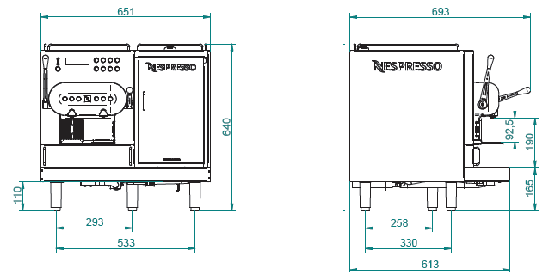

  - A free space of at least 50 mm is required around all sides of the machine's casing to ensure proper heat dissipation and service access.
  - The surface on which the coffee machine will stand must have a centrally located hole for the drainage hose.
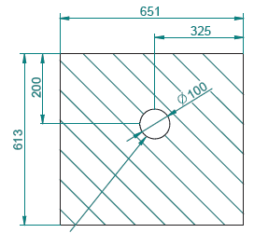
  - The placement of the machine must be level, stable, horizontal, and sufficiently robust to support the weight of the machine – 80 kg (max 100 kg).
  - The installation site should provide good ventilation. Ambient temperature should be between 16ºC - 32°C. Installation inside buildings only. Use in open spaces is not permitted.
  - The machine must not be placed on hot or heated surfaces.
  - Space must be provided near the machine for an external water filter (cylinder 530 mm high and 130 mm in diameter).
NOTE! For preparing milk-based beverages, the machine uses cold milk at a temperature of 5 ºC. The refrigerator in the machine only maintains the milk temperature at this level. Therefore, it is required that the customer has a refrigerator that can cool the milk to 5 ºC.

- Electrical Supply

  - There are two versions of the Aguila machine available: single-phase and three-phase.

Model | Required Voltage | Maximum Power Consumption | Maximum Supply Current
AG220/1 | 220V - 240V (1 faza) | 3800W | 15,8 A
AG220/3 | 380V - 415V (3 fazy) | 4800W | 9,1 A /per phase

  - The power connection must be equipped with a detachable socket or, if hardwired, a switch on all phases to allow for complete disconnection of power.
  - The power source should be independent, dedicated only to this machine, with the current capacity specified above to avoid voltage drops under full load.
- Water Supply
  - The Aguila machine is designed for direct water connection.
  - Cold water supply with a 3/8” connection, a cut-off water tap required.
  - The distance from the machine to the filter, and from the filter to the connection, should not exceed 1.5 m.
- Water pressure from 2 to 4 bars. If higher, a pressure reducer installation is necessary.
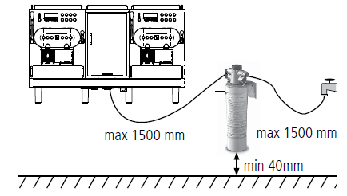(The diagram shows Aguila 420).

- Water Drainage (wastewater)
  - The machine during operation discharges water and wastewater associated with the cleaning and rinsing process.
  - Provision must be made for the disposal of this water and wastewater centrally, under the machine, through the drainage hose via a hole in the countertop, into the sewer system.

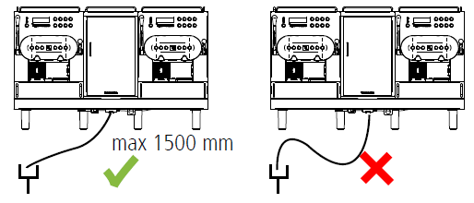

On behalf of the Client, I confirm, That the installation site meets the above conditions.

[Place, Date] [Name] [Signature]

